# National University of Computer and Emerging Sciences



**Programming Fundamentals Lab Manual 3**

|  |  |
| --- | --- |
| Course Instructor | Ms. Anosha Khan |
| Lab Instructor(s) | Ms. Samia Akhter  Mr. Wajahat Ali Khan |
| Section | BSE-1A |
| Semester | Fall 2022 |

Department of Computer Science FAST-NU, Lahore, Pakistan

# Objective:

## Introduction to C++

1. **How to compile C++ code**

## Simple arithmetic problems solving

**Activity # 1**

Write a C++ program that prints your name.

**Activity # 2**

Write a C++ program to print “your name, roll no., degree, section and lab number” in the following format.

******************************************************************

******************************************************************

************************ Welcome to Programming Fundamentals

Name: Sonia Anum

Roll #: Mscs19044

Degree: MS (CS)

Section: A

Lab: 03

******************************************************************

******************************************************************

************************

**Activity # 3**(Calculate area of Rectangle)

Take two inputs from user (keyboard) length and breadth of rectangle. Compute

the area of rectangle given by: area = length*breadth

|  |  |
| --- | --- |
| **Step-1**: Create a console application. | **Open Visual studio and create a console application** |
| **Step-2**: Declare int variables length, breath and area. | int length; int breadth; int area; |
| **Step-3**: Print a message for user to input length. | cout << "Please enter length of rectangle: "; |
| **Step-4**: Take input from user/keyboard length. | cin >> length; |
| **Step-5**: Print a message for user to input breadth. | cout << "Please enter breadth of rectangle: "; |
| **Step-6**: Take input from user/keyboard breadth. | cin >> breadth; |
| **Step-7**: Calculate area according to formula by multiplying length and  breadth, and store the result in “area”  variable. | area = length * breadth; |
| **Step-8**: Print appropriate message and area. | cout << "Area of rectangle is " << area; |

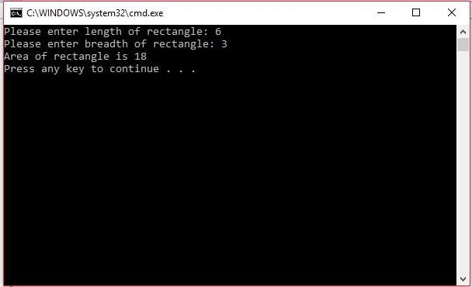Output

**Activity # 4**

Use float data type for (length, breadth and area) in activity#3 and use fractional

Numbers (length and breadth) to compute area and print the area.

**Activity # 5**

Write a program that takes height of a person as input in feet and inches. The program should then convert the height in centimeters and display it on screen.

Your program should

1. Input the length in feet and inches.

2. Convert the length into total inches.

3. Convert total inches into centimeters.

4. Output the height of person in inches as well as in centimeters.

Following fact might be useful for creating the programs.

**1 Foot = 12 inches**

**1 Inch = 2.54 centimeters**

**Activity # 6**

There is an ice-cream parlor which serves three flavors of ice cream: strawberry,

chocolate, and vanilla.

One by one, the user is asked the number of scoops that will be needed for each flavor. After that depending on the entered data, you have to calculate the final bill and print it. The price of one scoop is 100.

## The prices above are without GST the final bill has to have GST included i.e. 17%

**Sample Run**

**Enter # of scopes you wanted**

Strawberry: 2 Chocolate: 0 Vanilla: 3

**Output**

Total Bill: 500

**Activity # 6**

Write C++ code to solve the second-degree equation aX^2 + bX + c= 0 for any real

numbers a, b and c. The program takes the values of a, b and c as input from the user, and calculates X.

Note: real numbers are taken in float.

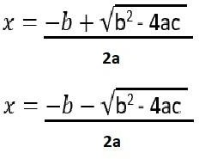

Example: This is for your understanding. Your code must work for any value of a, b, and c.

**Input**: Enter a: 1

Enter b: -1

Enter c: -6

**Output**: X=3, -2

**Activity # 7**

Take marks of 5 subjects separately from the user. Max marks of 1 subject are 100. Calculate

the percentage of total marks and print it. If the percentage is above 50 grade the student with P and if the student has greater than 45% and less than 50%, find 3% of the gained numbers of student and than add in its total marks. If number becomes greater than 50% grade the student P otherwise F. And last if the student has less than 45% marks grade the student with F. Example

**Input:**

Enter marks of 5 subjects:

Subject1= 75

Subject2= 80

Subject3= 71

Subject4= 90

Subject5= 65 **Output:**

The Percentage is 76.2

# END